Should Haves

1) Login Credentials to Start and Stop the script through the GUI
1a) If logged in, and the connection fails, it should keep trying for 15m to establish the connection with an interval of 1m.
1b) If the login is not successful then an alert should be sent to MS-Teams.

2) Application should run 24x7
2a) In case of internet connection failure, points 1a and 1b should be applied.

3) Maintain a Super-Folder that should contain: All Python Libraries, Python Scripts required to run the application (Avoid using PIP Install), Other Configuration data (e.g. OPC-DA/UA Server Name), SQL Server Name, Schema etc. (in case storage is to be done in SQL)

4) Application should be able to read the Tags from pre-filled MS-Excel file.

5) Necessary Condition: Every Tag should have the same time stamp for the same run.
5a) Data resolution <=1m
5b) Mandatory coloumns in O/P .csv file:
- Datetime (yyyy-mm-dd hh:mm:ss),
- Tagname,
- Value,
- Quality

6) Folder Structure: Create one .csv file every 15m with folder structure and nomenclature shown below:
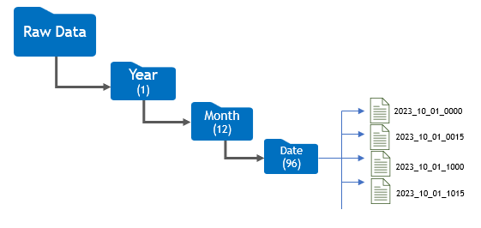

7) Output Data: Provide the flexibility to store either in .csv or in MS-SQL locally.
8) LabView approach for Data Ingestion from OPC-UA and -DA (Python)
9) Documentation file handover for replication of existing code
